
HOWARD COAD ELEMENTARY SCHOOL

431 Ave T North

Saskatoon, Saskatchewan, Canada, S7L 3B5
Phone: (306) 683-7260
Fax: (306) 657-3917
www.spsd.sk.ca
E-Mail: HowardCoadSchool@spsd.sk.ca

Principal: Mrs. Jaime Schroeder Vice-Principal: Miss Amy Basaraba
Board of Education Trustee: Mr. Cameron Scott

Dec. 7, 2017

Dear Parents and Caregivers,

In the process of saving more than $1 million in our 2017-18 transportation budget, Saskatoon Public Schools has integrated many of our bus routes with those of Greater Saskatoon Catholic Schools. The separate school division has a long-standing tradition of early dismissal on the last afternoon before the Christmas break.

In order to provide safe and efficient transportation arrangements and maintain alignment of our practices, for this year our school division is authorizing a corresponding early dismissal for all our schools on Friday, December 22.

On that day, students at our school will be dismissed at 2:30 p.m.

If you have any questions, please do not hesitate to contact the school.

Sincerely,

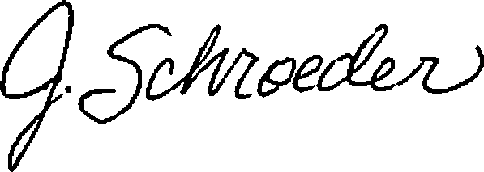

Jaime Schroeder, Principal
Howard Coad School

cc. Lisa Fleming, Superintendent of Education

